Civil war in Liberia

UNSC Resolution: | 866
Date of adoption: | 22-Sep-1993
Operative paragraph: | 9
Demand number: | 866,0911

Sarah-Myriam Martin-Brûlé

Wording of demand

conclude expeditiously, and no later than 60 days after its installation, a Status of Mission Agreement with the United Nations to facilitate the full deployment of UNOMIL

List of addressees of the demand

Government of Liberia

Short-term compliance

Description of the addressee(s)’ conduct

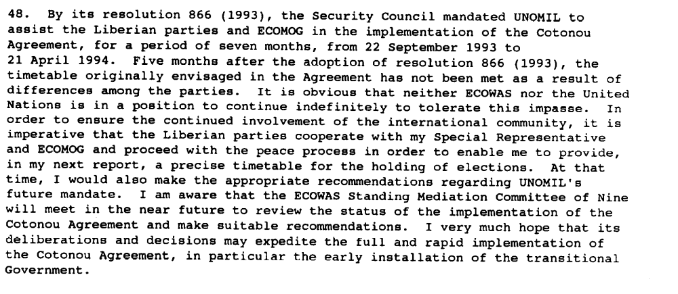
Report of the Secretary-General, 14 February 1994, S/1994/168

“As to the deployment of UNOMIL, the Secretary-General reported that following the adoption of Security Council resolution 856 (1993) on 10 August 1993, the advance party of military observers began arriving in Liberia. The Chief Military Observer arrived in the country on 10 October 1993 and by mid-December there were 166 UNOMIL military observers. UNOMIL was fully deployed by the end of December. »
United Nations Observer Mission in Liberia,
http://popp.gmu.edu/peace/unomil.html

Assessment

Short-term compliance
No or marginal compliance (1) | Medium low compliance (2) | Medium high compliance (3) | X Full or almost full compliance (4)

Considerations underlying the assessment

A status of mission agreement was concluded in 1993.

Medium-term compliance

Description of the addressee(s)’ conduct

“Two years later, the Secretary-General still referred to the status-of mission agreement concluded with LNTG in 1993:

‘The Council of State has requested that all communications or requests concerning the Liberian factions should be channelled through the Disarmament and Demobilization Commission, which is charged with promulgating and supervising national policy on disarmament and demobilization. The Council stated that such requests would include activities and reports of the Cease-fire Violations Committee, UNOMIL and ECOMOG deployment and non-governmental organization (NGO) escort and security provisions. My Special Representative has assured LNTG that UNOMIL will cooperate with the Commission in its work. At the same time, he clarified that the Government's request should not alter the Cease-fire Violations Committee mechanism provided for under the peace accords. In addition, he confirmed that, while UNOMIL will continue to inform LNTG of its activities, UNOMIL must continue to enjoy complete freedom of movement throughout Liberia, in accordance with its mandate and the status-of-mission agreement concluded with LNTG in 1993. After consultation with the humanitarian community, my Special Representative informed LNTG that he welcomed its provision of escorts for humanitarian activities. He pointed out, however, that care must be taken to ensure respect for the principles and protocols governing the delivery of humanitarian assistance and to allow the humanitarian community freedom of movement in carrying out its work.”
Fifteenth Progress Report of the Secretary-General on the United Nations Observer Mission in Liberia,
http://www.un.org/french/docs/sc/s199647.htm

Assessment

Medium-term compliance
No or marginal compliance (1) | Medium low compliance (2) | Medium high compliance (3) | X Full or almost full compliance (4)

Considerations underlying the assessment

The demand addressees concluded a status of mission agreement within the two years following this demand.

Depth of demand

Assessment

Level of depth of demand
X Low depth of demand (1) | Medium depth of demand (2) | High depth of demand (3)

Considerations underlying the assessment

There was no risk in complying for this demand. On the contrary, as Ellis explains:

“(..) the Secretary-General of the UN established a United Nations Observer Mission (Unomil) after complains by the NPFL that Ecomog was not an impartial force, since it had taken such an active role in fighting against the NPFL in the past.’ (Ellis 1999: 101)
Ellis, Stephen. 1999. The Mask of Anarchy. New York University Press.

Level of confidence about coding decisions

Level of confidence about coding decision
Extremely high | X High | Moderate

Comments to IPI (if any)

